 

SILAS Conference 2021Programme

Society for Irish Latin American Studies

Estudios Irlandeses y Latinoamericanos

ABEI - Associação Brasileira de Estudos Irlandeses

Cátedra de Estudos Irlandeses WB Yeats

Universidad de São Paulo, Brasil

Asociación de Estudios Irlandeses del Sur, Argentina

Universidad del Pacífico, Perú

Proyecto Especial Bicentenario, Perú

____________________________________________________________________________

**Eighth Biannual Conference**

_____________________________________________________________________________

**Commemoration, Memory, and Dialogue with the Past**

**Ireland – Latin America**

**Universidad del Pacífico, Lima Perú**



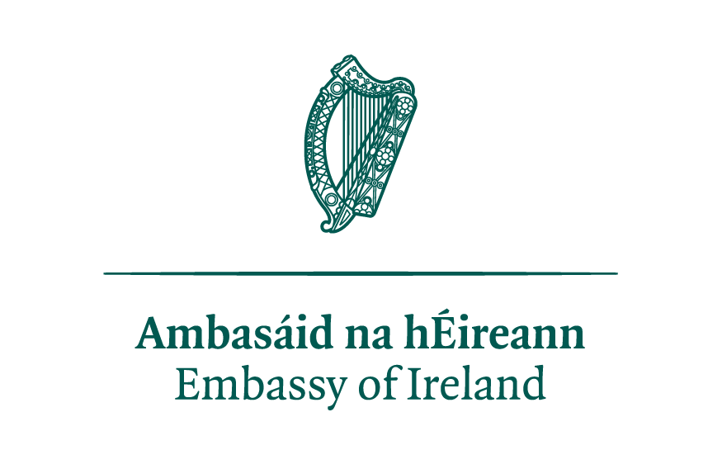

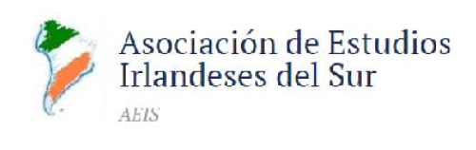



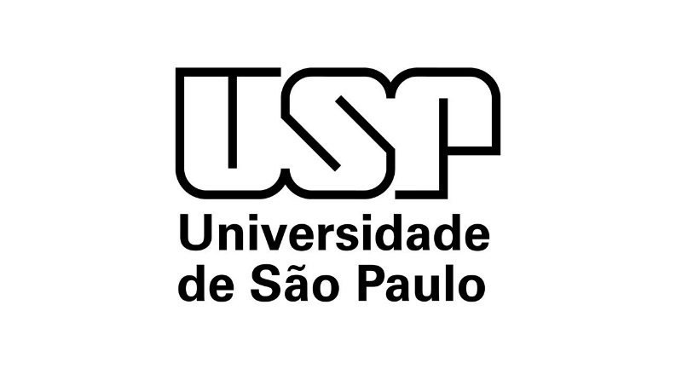

**Organizing Committee**

***Chairs:***

**Gabriela McEvoy (Lebanon Valley College, United States)**

**Martín Monsalve (Universidad del Pacífico, Lima, Perú)**

**Margaret Brehony (SILAS President)**

**Mariana Bolfarine (President of ABEI / UFR, Brazil)**

**Justin Harman (President of Asociación de Estudios Irlandeses del Sur, Argentina)**

**Laura Zuntini Izarra (W.B. Yeats Chair/USP, Brazil)**

**María Graciela Eliggi (Universidad Nacional de La Pampa, Argentina)**

**Nuala Finnegan (University College Cork, Ireland)**

**Giselle González (Concordia University, Canada)**

**Clíona Murphy (California State University Bakersfield, United States)**

**Many thanks to**

**Ashley Klawitter (LVC Administrative Assistant), Liam Schmidt (LVC Undergraduate),**

**Grace Parks (LVC Undergraduate), Ana Carolina Vilalta Caetano (USP Undergraduate),**

**and Victor Augusto Pacheco (USP Postgraduate)**

**for their support to the organizing committee**

**Commemoration, Memory, and Dialogue with the Past**

**Ireland – Latin America**

Desires and aspirations for independence from Imperial rulers and the fight against colonial systems are ideas and dreams that were common to Ireland and Latin America. Revolutionary movements arose against Spanish, British, and Portuguese colonialism. 2021 is a significant year for Peru, Mexico, Central America (Costa Rica, El Salvador, Guatemala, Honduras, Nicaragua, and Panama) as they commemorate their national independence bicentennials. Likewise, the decade 2012-2022 is the Decade of Centenaries marking historical events in the formation of modern Ireland. This conference seeks to create a space for discussion and an exchange of ideas about the meaning of the making of a nation with regards to Ireland and these countries. The challenges involved in both nation-building and the documenting of that process will receive attention, and the conference is interested in analyses of cultural responses to nation-building in the form of press and media coverage, writing, art or any form or popular culture including song.

The conference will also explore the many transnational dialogues between Ireland and Latin America over the process of nation-building and independence and the reception of these ideas. Finally, the conference is open to scholarly investigations of the multiple commemoration processes of independence and revolution in both Ireland and Latin America as a way of opening fruitful comparative pathways.

The conference would like to bring together scholars from across disciplines who are interested in connections between Ireland, Latin America, the Caribbean, and the Iberian Peninsula. We invite individual proposals for twenty-minute presentations (papers/posters) or for panels of three people exploring a similar theme.

**The following themes are suggested**

Historical Memory and its Social Function Gendered Narratives of Independence

“Invention of Tradition” Reproducing the Nation

Constructions of Nationalism Biographical Writings

Comparative Colonialisms and Decolonization Letters and Diaries

Migrations, Mobility, Place, Identity Music, Film, Literature

Transnational Solidarities in Independence Processes Cultural and Textual Translations

**Conmemoración, memoria y diálogo con el pasado**

**Irlanda – Latinoamérica**

Deseos y aspiraciones de independencia de las autoridades imperiales y la lucha contra los sistemas coloniales son ideas y sueños que tuvieron en común Irlanda y Latinoamérica. Los movimientos revolucionarios surgieron contra el colonialismo de España, Gran Bretaña y Portugal. El 2021 es un año significativo para el Perú y Centroamérica (Costa Rica, El Salvador, Guatemala, Honduras, Nicaragua y Panamá) ya que conmemoran el bicentenario de su independencia nacional. Asimismo, la década del 2012-2022 es la Década de Centenarios que marca los sucesos históricos en la formación de la Irlanda moderna. Esta conferencia busca crear un espacio de discusión y de intercambio de ideas acerca del significado de la construcción de la nación con relación a Irlanda y estos países. Se prestará atención a los desafíos involucrados en la construcción de la nación y en la documentación del proceso. La conferencia está interesada en el análisis de las respuestas culturales ya sea de la prensa y de los medios de cobertura, la escritura, el arte o cualquier otra forma de cultura popular incluyendo canciones.

La conferencia también explorará los distintos diálogos transnacionales entre Irlanda y Latinoamérica sobre el proceso de construcción de la nación e independencia y la recepción de estas ideas. Finalmente, la conferencia está abierta para investigadores académicos de los múltiples procesos conmemorativos de independencia y revolución tanto en Irlanda como en Latinoamérica como una forma de abrir productivos estudios (caminos) comparativos.

Se sugieren los siguientes temas:

Memoria histórica y su función social Narrativas de género de independencia

“La invención de la tradición” Reproduciendo la nación

La construcción del nacionalismo Escrituras biográficas

Colonialismo y descolonización comparativo Cartas y diarios

Migraciones, movilidad, espacio, identidad Música, cine, literatura

Solidaridades transnacionales en los procesos Traducciones culturales y textuales

de independencia

**Commemoration, Memory, and Dialogue with the Past:**

**Ireland – Latin America**

Universidad del Pacífico, Lima, Perú (Virtual) | November, 23-26, 2021

**Conference Schedule**

**The sessions are scheduled according to Peruvian Standard Time.**

**DAY/Día 1 – TUESDAY/MARTES NOVEMBER 23, 2021**

|  |  |
| --- | --- |
| 8:30-9:00am | [Conference Opening/ Ceremonia de Apertura](https://youtu.be/PipoTW3qxms)  **Dr. Arlette Beltrán**  Universidad del Pacífico, Lima, Perú  **H.E. Mr. Paul Gleeson**  Ambassador of Ireland in Chile, Perú, and Ecuador  **Dr. Margaret Brehony**  Society for Irish Latin American Studies (SILAS)  **Dr. Martín Monsalve**  Universidad del Pacífico, Lima, Perú |
| 9:00-10:30am | [Keynote Roundtable](https://youtu.be/-PJx_v4QVvw)  **Historical Perspectives of Peruvian Independence and its Implications**  **Chair/Moderator: Martín Monsalve,** Universidad del Pacífico, Lima, Perú  **Carmen McEvoy**, University of the South (United States), Proyecto Especial Bicentenario (Perú)  “Empezar el mundo de nuevo”: Teoría y praxis revolucionaria durante el proceso independentista  (20 minutes)  **Chuck Walker,** University of California, Davis (United States)  “Southern Exceptionalism: Cusco and the Peru’s War of Independence” (20 minutes)  **Miguel Ángel De Marco**, Presidente del Instituto Nacional Browniano de la República Argentina  “Guillermo Brown, un irlandés en las costas del Pacífico antes de la independencia de Perú”  (20 minutes)  **Roberto L. Elissalde**, Vicepresidente de la Academia Argentina de Artes y Ciencias de la Comunicación e Historiador Porteño 2021, Buenos Aires (Argentina)  “Los irlandeses con San Martín en la independencia del Perú” (20 minutes) |
| 10:45-11:45am | [Roundtable 1](https://youtu.be/Ccmdgb8VP3k)  **Roger Casement**  **Chair/Moderator: Mariana Bolfarine,** University of São Paulo, Brazil  **Brendan Tobin, “**100 Years of Platitudes: Casement and Struggle for Intercultural Justice”  (30 minutes)  **Edward Walsh,** independent scholar  “Casement Crotty Letters” (30 minutes) |
| 11:45-12:00pm | [Lunch and Cultural Activity](https://youtu.be/yF65k1W-Dgs) |
| 12:00-1:25pm    1:30-2:30pm | ***Secrets from Putumayo* (if you received the link, please watch the movie on your own at 12:00pm**  **on Tuesday, November 23, 2021, before the movie discussion)**  [Roundtable 2](https://youtu.be/MSMoqGVXx_A)  **Chair: Mr. Paul Gleeson, Ambassador of Ireland in Chile, Perú, and Ecuador**  **Aurélio Michiles in dialogue with Esther Hamburger** (University of São Paulo, Brazil)**, Mariana Bolfarine** (University of São Paulo, Brazil), **and Laura Izarra** (University of São Paulo, Brazil) |
| 2:30-3:00pm | [Cultural Activity](https://youtu.be/H586mXpJlko)  **Casement Photography Exhibition**  **Angus Mitchel,** (Historian, Ireland) |
| **DAY/Día 2 – WEDNESDAY/MIÉRCOLES NOVEMBER 24, 2021** | |
| 8:30-9:15am | [Keynote Speaker](https://youtu.be/xygdM0YGQk4)  **Irish Revolution and the Peruvian Media**  **Chair/Moderator: Margaret Brehony,** Society for Irish Latin American Studies (SILAS)  **Gabriela McEvoy,** Lebanon Valley College (United States)  “Discourses in Conflict: The Irish Revolutionary Movements from the Peruvian Perspective”  (30 minutes) |
| 9:30-10:45am | [Panel 1 – Art and Poetry between Ireland and Latin America: A Conversation](https://youtu.be/c-m0QVNp70k)  **Chair/Moderator: Nuala Finnegan**, University College Cork (Ireland)  Dylan Brennan, poet (Mexico City); Isabela Basombrío Hoban, visual artist (Castlebar),  John Ennis poet (Waterford); Giovanni Mangiante, poet (Lima) (75 minutes) |
| 11:00-11:45am | [Keynote Speaker](https://youtu.be/FkmTB1phLmQ)  **Chair/Moderator: Nuala Finnegan**, University College Cork (Ireland)  **Gender, Punishment, and Violence in Ireland**  **Linda Connolly,** Maynooth University (Ireland) (30 minutes) |
| 11:45-12:30pm | [Lunch and Cultural Activity](https://youtu.be/o4D1tAepdGo)  **Exhibition: “Las Primeras”**  **Karen Bernedo Morales** (curator), Universidad Científica del Sur (Perú) |
| 12:30-2:15pm | [Panel 2 – Independence](https://youtu.be/xG3W1dMCIBE)  **Chair/Moderator: Justin Harman**, Asociación de Estudios Irlandeses del Sur (AEIS)  **Roberto Arancibia,** Investigador Asociado del Centro de Estudios Históricos de la Universidad Bernardo O´Higgins, Santiago de Chile  “Bernardo Higgins Riquelme, un hijo de Irlanda y un gran amigo del Perú” (20 minutes)  **María Eugenia Cruset,** CONICET/Universidad Nacional de Quilmes, Argentina  “Los ‘Libertadores’: O’Connell, Bolívar, San Martín, y O’Higgins, una comunión de ideas” (20 minutes)  **Roberto L. Elissalde**, Vicepresidente de la Academia Argentina de Artes y Ciencias de la Comunicación  “Un porteño con ascendencia irlandesa en la independencia del Perú” (20 minutes) |
| 2:30-3:30pm | [Panel 3 – The Media](https://youtu.be/K1IpTvJGtfk)  **Chair/Moderator: María Graciela Eliggi,** Universidad Nacional de La Pampa (Argentina)  **Maria Verónica Repetti,** Universidad del Salvador (Argentina) (15 minutes)  **Paula Ortiz,** Universidad del Salvador (Argentina) (15 minutes)  **Leonel Kodnia,** Universidad del Salvador (Argentina) (15 minutes)  “Critical History of *The Southern Cross*” |

**DAY/Día 3 – THURSDAY/JUEVES NOVEMBER 25, 2021**

|  |  |
| --- | --- |
| 8:30-9:30am | [Panel 4: Meanings and Traditions](https://youtu.be/9DLcup4Ho6k)  **Chair/Moderator: Paula Ortiz,** Cátedra Extracurricular de Estudios Irlandeses USAL y miembro de AEIS  **Paula Brain,** Universidad Nacional de la Patagonia San Juan Bosco (UNPSJB) (Argentina)  “Resignificación de la brujería irlandesa desde baja Edad Media hasta sus inicios de la vigésima centuria” (15 minutes)  **Cathal Billings,** University College Dublin (Ireland)  “The Invented Tradition of Gaelic Games and the GAA’s ban on Foreign Sports”  (15 minutes) |
| 9:45-11:15am | [Panel 5 - Challenging the boundaries of entrepreneurship: the meanings of motherhood amongst Latin American migrant women entrepreneurs in Ireland](https://youtu.be/9nu-xUV1jwQ)  **Chair/Moderator: Clíona Maher**, University College Cork (Ireland)  **Ana Cruz García,** Munster Technological University(Ireland**), Rosalía Shadid Vázquez,**  **Viridiana Kingston-Castro**, and **Carmen Fitzgerald** (90 minutes) |
| 11:30-12:30pm | [Panel 6 - James Joyce](https://youtu.be/NNCaDiOCA_0)  **Chair/Moderator: Giselle Gonzalez**  **Camila Hespanhol Peruchi,** State University of Campinas (Brazil)  “An Untold History: Translations of Ulysses’s excerpts in Brazil” (20 minutes)  **Pedro Luís Sala Vieira,** Fluminense Federal University (Brazil)  “The Shakespearean presence in the Brazilian translation of James Joyce’s Ulysses: an analysis of ‘Telemachus’” (20 minutes) |
| 12:30-1:00pm | [Lunch and Cultural Activity](https://youtu.be/fT9ItTJLgDU) |
| 1:00-2:00pm  2:15-2:45pm | [Panel 7 - Irish Literature](https://youtu.be/CsM2i3AKDww)  **Chair/Moderator: Maria Graciela Eliggi** (Universidad Nacional de La Pampa) (Argentina)  **Miriam Germani,** Universidad Nacional de La Pampa (Argentina)  “The Incorrigible Irishman: A Linguistic Analysis of the Rep. of R.C. in The Dream of the Celt and Valiant Gentlemen” (15 minutes)  **Magali Libardi,** Universidad del Salvador (Argentina)  “La traducción de literatura irlandesa en el contexto académico: el caso del taller de ´Voces irlandesas´” (15 minutes)  **Alessandra C. Rigonato,** Universidade Federal do Tocantins (UFT) (Brazil)  “Of Ghost and Troubles: Resonances of the Northern Irish Political Conflict in the Play *Sadie* by David Ireland” (15 minutes)  [Panel 8 - Irish Literature](https://youtu.be/sKTWBkAL_U8)  **Chair/Moderator: María Verónica Repetti**, Cátedra Extracurricular de Estudios Irlandeses USAL y miembro de AEIS  **Elaine Gaston,** poet and independent scholar  “Colonizing Language: Women’s Poetry from the Northern Part of Ireland” (15 minutes)  **Griselda Gugliara,** Universidad Nacional de La Pampa (Argentina)  “The Pull of Stars: female voices claiming justice” (15 minutes) |
| 3:00-4:00 pm | [Book Presentations](https://youtu.be/94T1pdEowts)  **Peter Pyne**  *The Irish and the Panama Railroad* (10 minutes)  **J.J. Delaney**, Universidad del Salvador (Argentina)  *Rodolfo Walsh. Cartas a Donald A. Yates (1954-1964)* (10 minutes)  **Paula Brain,** Universidad Nacional de la Patagonia San Juan Bosco (UNPSJP) (Argentina)  *Ni castillos, ni banquetes ni princesas. Miseria, evicción, genocidio, y resistencia en los cuentos populares irlandeses contemporáneos* (10 minutes)  **María Graciela Eliggi,** Universidad Nacional de La Pampa (Argentina)  *Translation of Lives: Roger Casement* by Angus Mitchell (10 minutes)  **Harry Dunleavy,** independent scholar  *Irish Immigration in Latin America* (10 minutes) |

**DAY/Día 4 – FRIDAY/VIERNES NOVEMBER 26, 2021**

|  |  |
| --- | --- |
| 8:30-9:45am | [Panel 9 - Politics and Memory](https://youtu.be/wYfCjGB4sOg)  **Chair/Moderator: Laura Izarra,** University of São Paulo, Brazil  **Justin Harman,** Asociación de Estudios Irlandeses del Sur (Argentina)  “1970’s Argentina – ‘The decade that keeps coming back’: Reflections of an Irish diplomat in Buenos Aires” (15 minutes)  **Cahal McLaughlin,** Queen’s University Belfast (Northern Ireland)  “The Prisons Memory Archive: A Conflicted Past in a Contested Present” (15 minutes)  **Vinicius García Valim,** Universidade Federal de Santa Catarina (Brazil)  “Nationalism as an issue in the reception to the *Field Day Anthology of Irish Writing*”  (15 minutes) |
| 10:00-10:45am | [Panel 10 - Irish Diaspora in the Southern Cone](https://youtu.be/PlmORj--elk)  **Chair/Moderator: Gabriela McEvoy**,Lebanon Valley College (United States)  **Viviana Keegan**, Universidad del Salvador (Argentina)  “El primer asentamiento de las Sisters of Mercy en Argentina (1856-1880): nueva mirada”  (15 minutes)  **Nell Buckley,** Utrecht University (The Netherlands)  "The Cork and Ross mission to Peru and the fall of Catholicism from Irish Public Memory  and Identity” (15 minutes)  **María Medina,** Maynooth University (Ireland)  “La escritura de Juan José Delaney hacia fines del siglo XX: la historia argentino-  Irlandesa en *Tréboles del sur*” (15 minutes) |
| 11:00-12:30pm | [Panel 11 - Interculturality](https://youtu.be/oLgwKhPAXbg)  **Chair/Moderator: Clíona Maher,** University College Cork (Ireland)  **Fernando Pinzas**, Universidad de Lima (Perú)  “La construcción de una identidad en el rock peruano” (15 minutes)  **María Torres,** University College Cork, Pontificia Universidad Pontificia Católica del Perú  “Reivindicación de la identidad indígena y libre determinación de los pueblos/Bicentenario”  (15 minutes)  **María del Carmen Arencibia O’Reilly,** Biblioteca Pública Provincial “Rubén Martínez Villena”,  La Habana (Cuba)  “Experiencias de interculturalidad desde la lectura en la Biblioteca Pública Rubén Martínez Villena” (15 minutes) |
| 12:30-1:00pm | [Lunch and Cultural Activity](https://youtu.be/Zux1y_GL9i0)  **La Virgen de Paucartambo**  **Pilar Pedraza and Miguel Rubio**, Yuyachkani (Perú) |
| 1:00-1:45pm | [Keynote Speaker](https://youtu.be/oFcmkfCiwug)  **Chair/Moderator: Margaret Brehony,** Society for Irish Latin American Studies  **Internationalisation of the Irish revolution**  Dermot Keogh, University College Cork (Ireland) (30 minutes) |
| 2:00-3:00pm | [Panel 12 - Irish Literature](https://youtu.be/-GJaAELRWT0)  **Chair/Moderator: Mariana Bolfarine,** Universidade de Sao Paulo (Brazil)  **Silvana Fernández,** Universidad Nacional de La Plata (Argentina)  “Poetics of the Irish Border in *Bad Blood* (1987) by Colm Tóibín and *The Rule of the Land* by Garrett Carr” (2017) (15 minutes)  **Liam Schmidt,** Lebanon Valley College (United States)  “Rethinking Seamus Heaney’s ´At a Potato Digging’: A Challenge to History’s Efforts to Explain the Past” (15 minutes)  **Rosalie Rahal Haddad**, Universidade de Sao Paulo (Brazil)  “Bernard Shaw: An Author Without a Birth Certificate” (15 minutes) |
| 3:00pm | [Closing](https://youtu.be/3uty3w8o4fA)  **Martín Monsalve**,Universidad del Pacífico (Perú) |